**COMPUTER ORGANIZATION AND ASSEMBLY LANGUAGE**

**LAB TASK 03**

Aliza Rizvi

58782

1. **Write a program to print the character A?**

**Code**

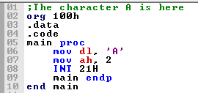

**Output**

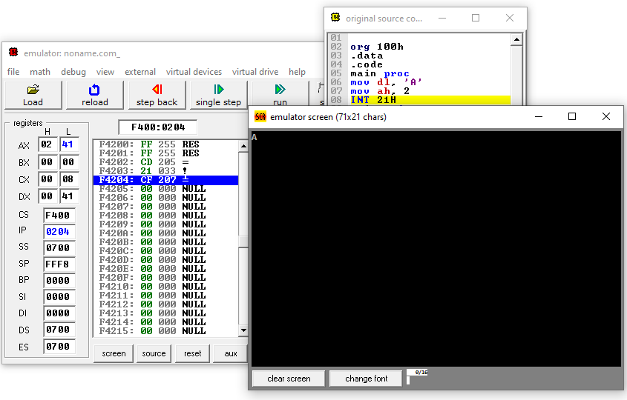

1. **Write a program to print the characters of your name?**

**Code**

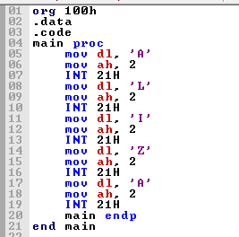

**Output**

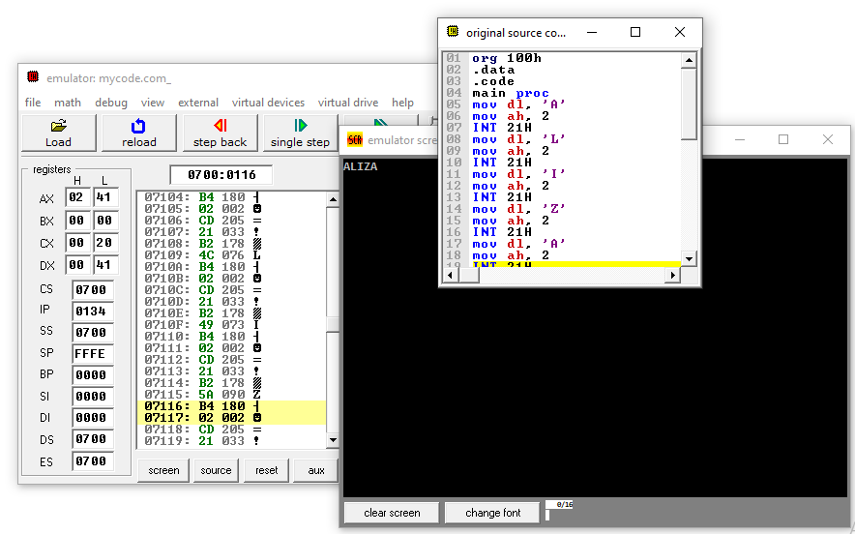

1. **Write a program that input a character from user is in lowercase, the program will convert it to uppercase and will display it on console after conversion.**

**Code**

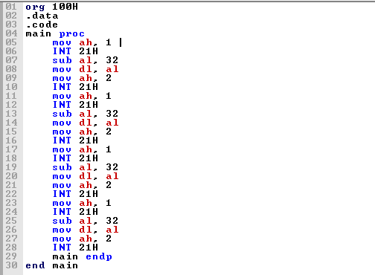

**Output**

